**Endpoint to retrieve a movie with all details of the movie**

**Input: {Movie Name}**

**End Point:** https://localhost:44355/api/Movie/GetMovieDetails?name=ABC

Sample Response:

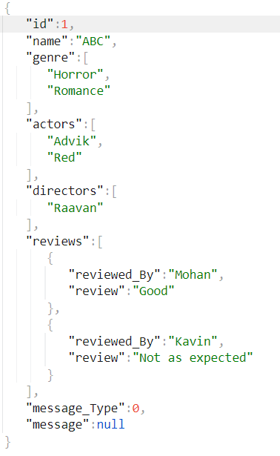

Response if the movie name does not exist

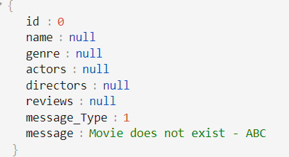

**Endpoint to retrieve an actor with a list of all movies.**

**Input: {Actor Name}**

**End Point:** https://localhost:44355/api/Actor/GetMovies?name=Advik

Sample Response:

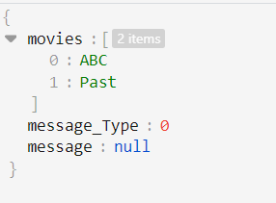

Response if the actor does not exist

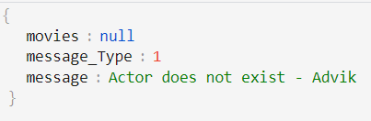

**Endpoint to list all movies by a genre.**

**Input: {Genre}**

**End Point:**  https://localhost:44355/api/Genre/GetMovies?genre=horror

Sample Response:

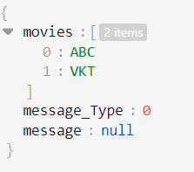

Response if the genre does not exist

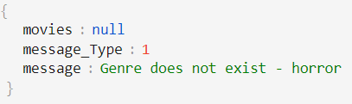

A job will run continuously which generate a report between 12 A.M to 1 A.M on a daily basis. Below is the sample content of the report.

{

"actorMovieCountList":[

{

"actorName":"Advik",

"movieCount":2

},

{

"actorName":"Red",

"movieCount":1

},

{

"actorName":"Raavan",

"movieCount":1

}

],

"genreCount":4,

"movieGenreCount":[

{

"genre":"Horror",

"movieCount":2

},

{

"genre":"Romance",

"movieCount":1

},

{

"genre":"Family",

"movieCount":1

},

{

"genre":"Thriller",

"movieCount":1

}

]

}